**Left Field Hotel**

**Starting Out:**

When you first start the game, you should begin in complete darkness.

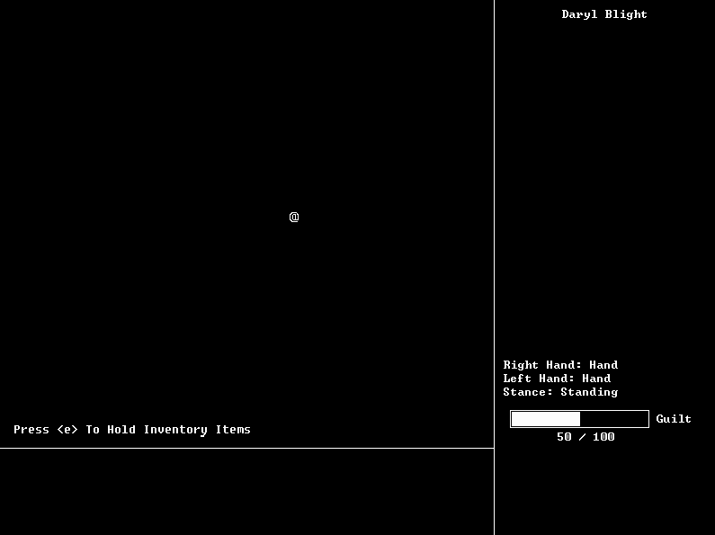

By pressing “e”, you will open a submenu showing the items in your inventory and allow you to select an item to equip (meaning to hold that item in your hand).



Make sure you have your numpad turned on! The numpad is where many of the game’s controls will take place. By press “8” (the up arrow) or “2” (the down arrow) on your numpad, you will be able to select which item you would like to equip.

To confirm a selection, press the middle key (5).

KEEP IN MIND: Whenever you are in the middle of a command such as this, you can press “0” on the numpad to cancel it.

After this is done, you will be asked which hand to hold the Match in.



Select either hand, it doesn’t matter since both of your hands are empty!

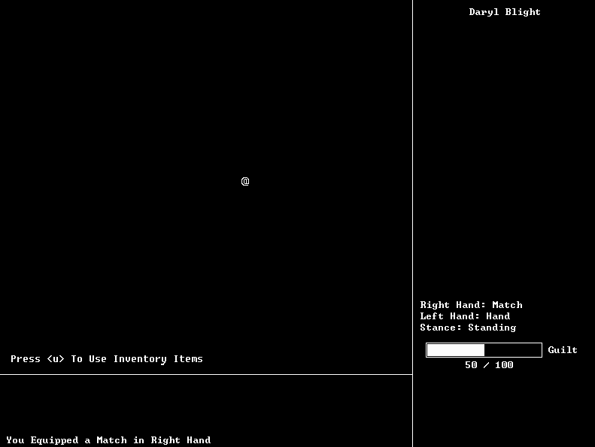

Now you’ve equipped your first item! You may do this do any item in the game, such as Knives, Flashlights, or Bandages.

Now you will be told to press “u” in order to use inventory items. You will go a similar submenu as when you wanted to equip an item. Choose to “Use” the Match.

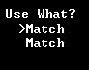

After doing so, you will notice that the Match has turned into a Lit Match. To view your inventory at any time press “i”. Lit Matches will create light around you as long as they are in your hand.

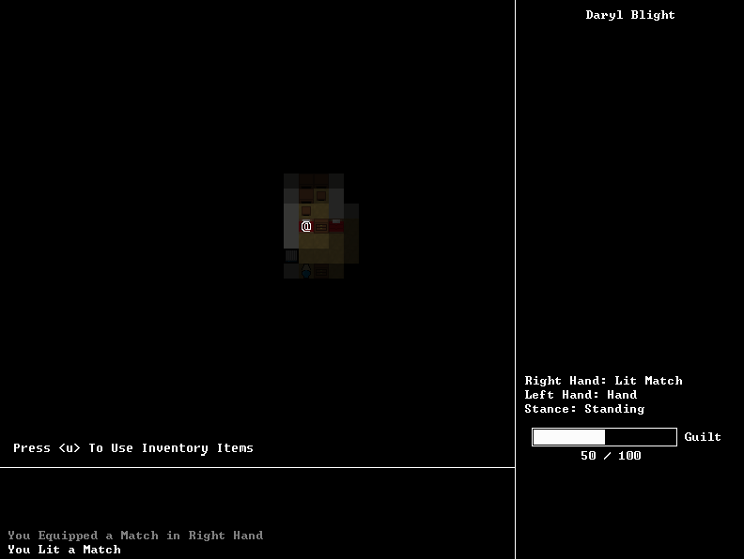

At this point, you can use the numpad to move around the room.

**Breaking Objects**

By pressing “b”, you can break certain objects such as Lamps, Tables, Cabinets, Windows, and more. Once you press “b”, you will be asked “Break What?”. Choose a direction with the numpad to attempt to break that object. If it is possible, the object will be broken.

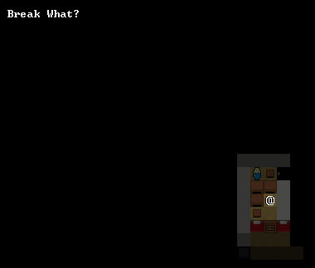

Here is a table after being broken.

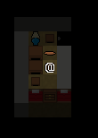

**Light and Operating Objects**

See the lamp? Light is very important in Left Field Hotel as will be explained later on. Try standing next to it and pressing “o”. The “o” key is the “Operate” key. It will allow you to operate certain objects. It will open windows, turn/off lamps, open/close cabinets and doors, and more. It may be good try to operate every object you see to discover if they serve any function!

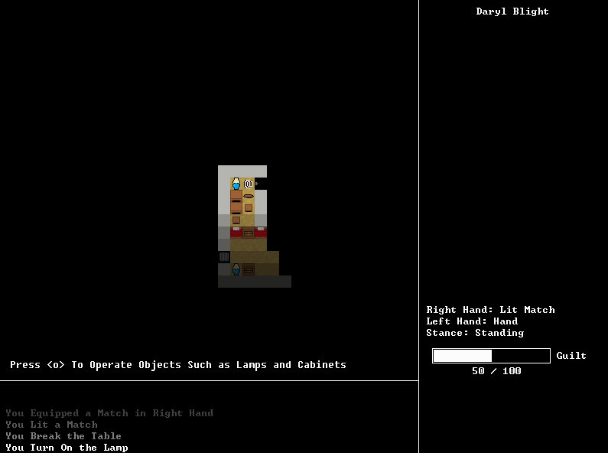

You can also try operating the cabinets, doors, and windows.

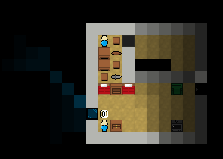

**Items**

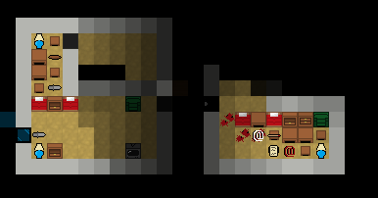

If you do some exploring you will find many things such as Matches, Knives, Hammers, Bandages, Portraits, Notes, and more.

Press “p” to pick up items from the ground. If your inventory is full, you can press “d” to drop them again.

Matches and, if you’re lucky, Flashlights are especially important to pick up. These will give you light. If you stay in the dark for too long, your Guilt Meter will begin to slowly increase. Once it reaches 100%, your character will begin to start hurting himself with Knives and Hammers. This can very easily kill you, so it’s a good idea to get into the light unless you are forced not to.

See that note on the ground?

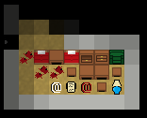

Certain items such as notes will progress the story and get you closer to escaping the hotel. To read such items, press “u” to “Use” them. Many items in the game are readable. Notes, News Articles, and more can be read, so try them all!

However, by reading the note, your Guilt Meter will permanently increase by 30 points. Such events will occur and are actually required to escape the hotel.

Also, by reading the Note, your hands will become “Bloody”…Is there any play where you can wash your hands? (Hint: Bathrooms).

**Being Followed**

When you explore for too long, you will start to be followed by an enemy. Whenever this event occurs, the music will become creepy, and a hint will pop up telling you that you are being followed (this will only occur for the first time. In the future, memorize the music that plays so that you can know!)

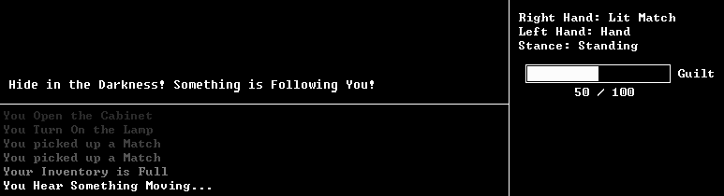

Enemies cannot be killed, even by Knives or Hammers. The only thing you can do is to hide!

Once you know when you are being followed, the first thing for you to do would be get rid of any lights surrounding you. Standing in the light will allow the enemy to easily find you.

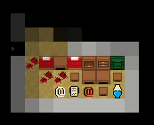

There are two things that we can do. We can either turn off the lamp, throw away our Lit Match, and hide or a corner, or we can go somewhere dark where there is no light. Let’s do the latter.

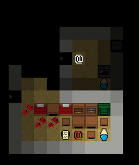

We need to hurry and hide! Let’s be sure to close any doors behind us to slow down the enemy. We now hear door thuds, meaning that the enemy is behind the door to the very left.

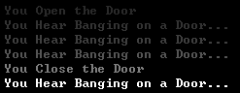

Next, we need to get rid of our Lit Match. We can either drop it, which will still create light in the room, or we can throw it out the window to permanently get rid of it.

First, go over to the window. Then press “b” to Break it.

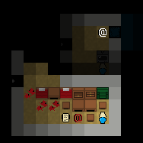

Now press “t”. This will allow you to Throw an item held in one of your hands. Our Lit Match is in our Right Hand, so let’s throw it out the window.

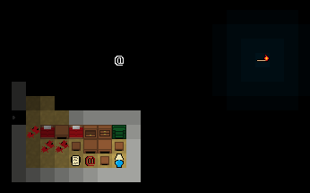

Good. Now we must feel around for a corner in the room, sit there, and wait until the enemy leaves (and try not to fall out of the broken window). If we weren’t fast enough or the enemy gets too close to us, then we will lose. Press “5” on the numpad to wait turns.

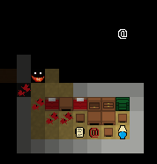

It may have noticed us!

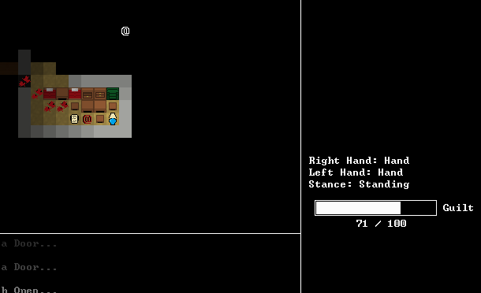

Notice that as we sit in the dark, our Guilt Meter begins to gradually increase. We cannot leave our spot, or we will be caught and lose, but we also cannot stay in the dark for too long, or we will begin to hurt ourselves and may end up dying. Let’s see what happens…

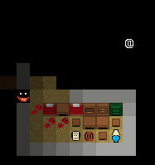

It’s beginning to leave! Let’s wait a bit longer before lighting a new match and creating light or it may notice us.

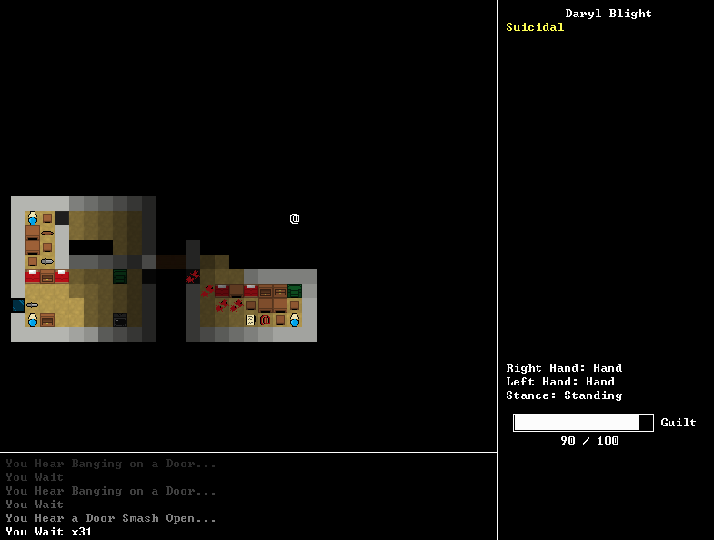

We made it. But barely! Our guilt has gotten very high and we are slightly suicidal. Let’s press “e” to equip a Match and the press “u” to use it to create a Lit Match.

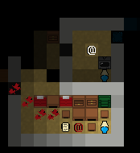

At this point, the tutorial is over. We can continue to explore the hotel, looking for things to further develop our understanding of the story and find a way out of the hotel.

**Important Miscellaneous Information**

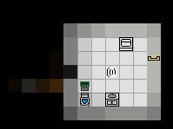

Bathrooms are rather special rooms. There is only one bathroom per floor. They contain toilets, special bathroom lights that can only be turned off by exiting the bathroom or breaking them, sink cabinets which contain bandages to stop bleeding, and tubs that can wash away blood (Hint: Didn’t the note we read put blood on our hands?)

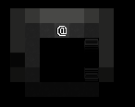

Staircases allow you to move between different floors. Each floor is different! Some events will only occur when you move through different floors.

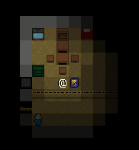

It looks like this room here was the location of a murder. Who committed this murder? And why is there a portrait on the ground? (Hint: Picking up the portrait will bring back bad memories. Is there any way for you to permanently get rid of that portrait?)

Police Cross Lines can be torn down by Breaking them (pressing “b”).

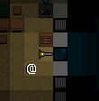

Flashlights offer more light than Lit Matches and remain permanently lit. At any time while using a flashlight you can Use (“u”) it to turn it on or off.

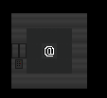

Elevators are the final destination. Once you complete all of the required objectives, an elevator will appear. You can call the elevator to the floor by pressing “o” to Operate the control panel.

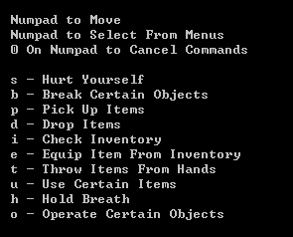

By pressing esc and selecting Controls, you can view all of the controls for the game. Be sure to view this! It contains commands not shown in this tutorial such as “s” to hurt yourself and “h” to hold your breath.